**CNN based Deaf - Mute People Sign Language to Text and Speech**

In this project using CNN we are recognizing hand gesture movement and to train CNN we are using following images shown in below screen shots

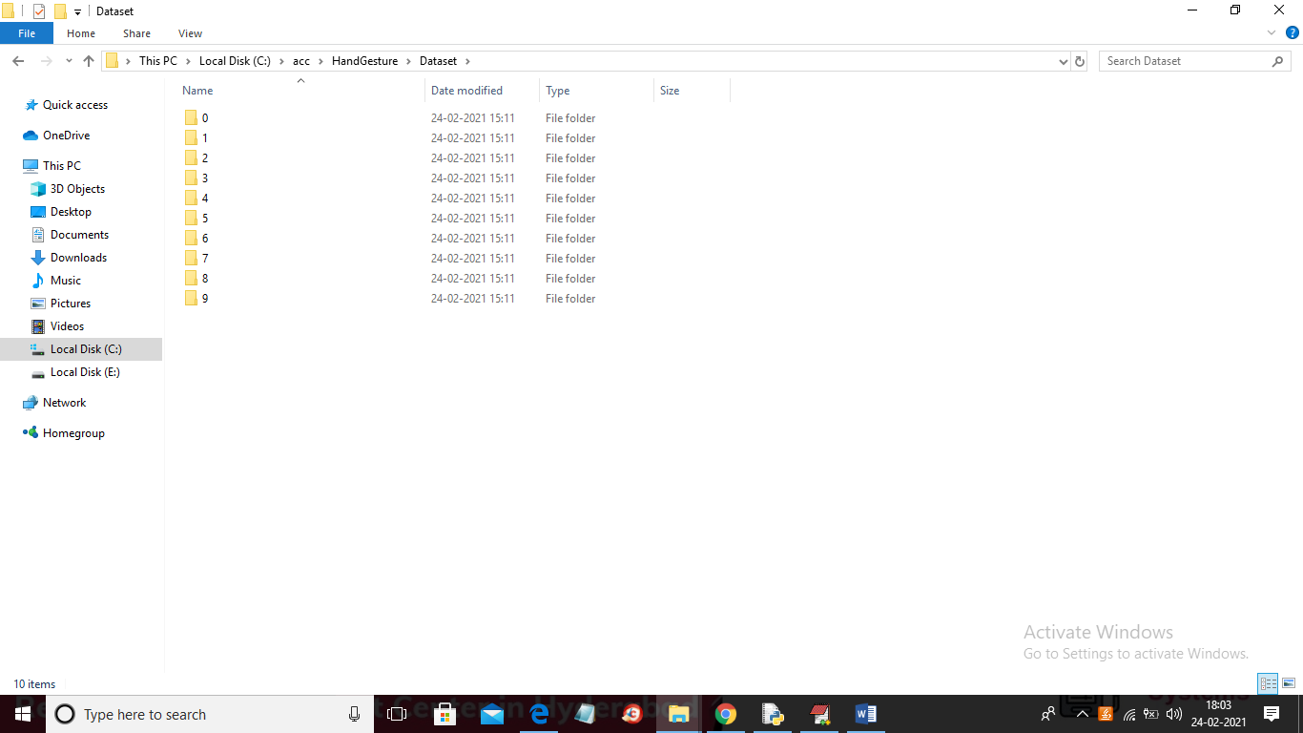

In above screen we can see we have 10 different types of hand gesture images and to see those images just go inside any folder

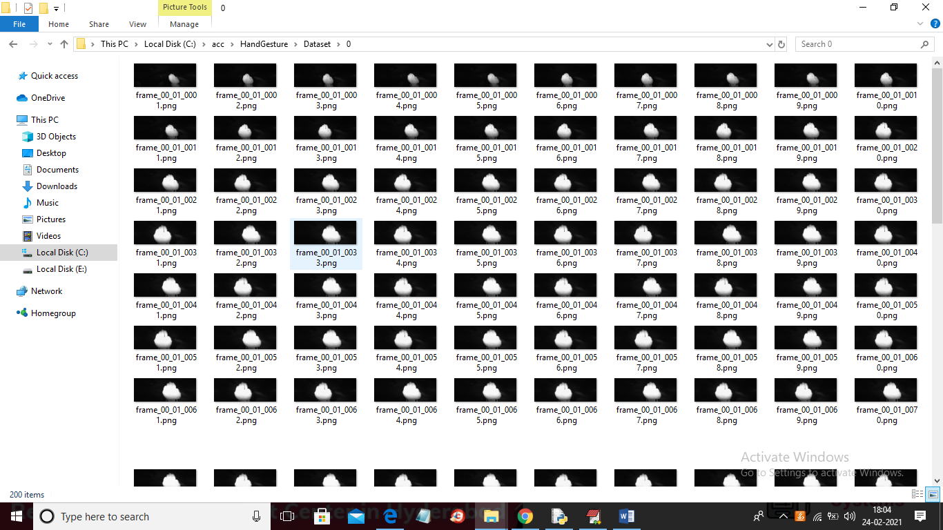

In above screen showing images from 0 folder and similarly you can see different images in different folders.

SCREEN SHOTS

To run project double click on run.bat file to get below screen

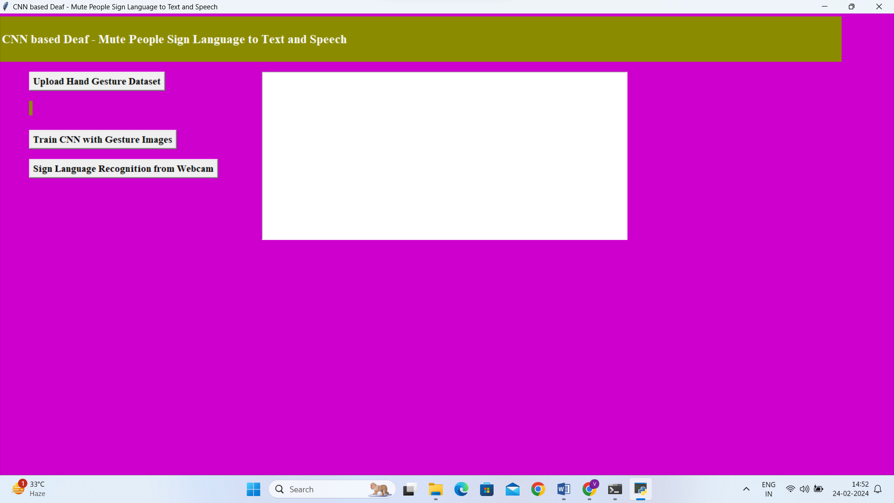

In above screen click on ‘Upload Hand Gesture Dataset’ button to upload dataset and to get below screen

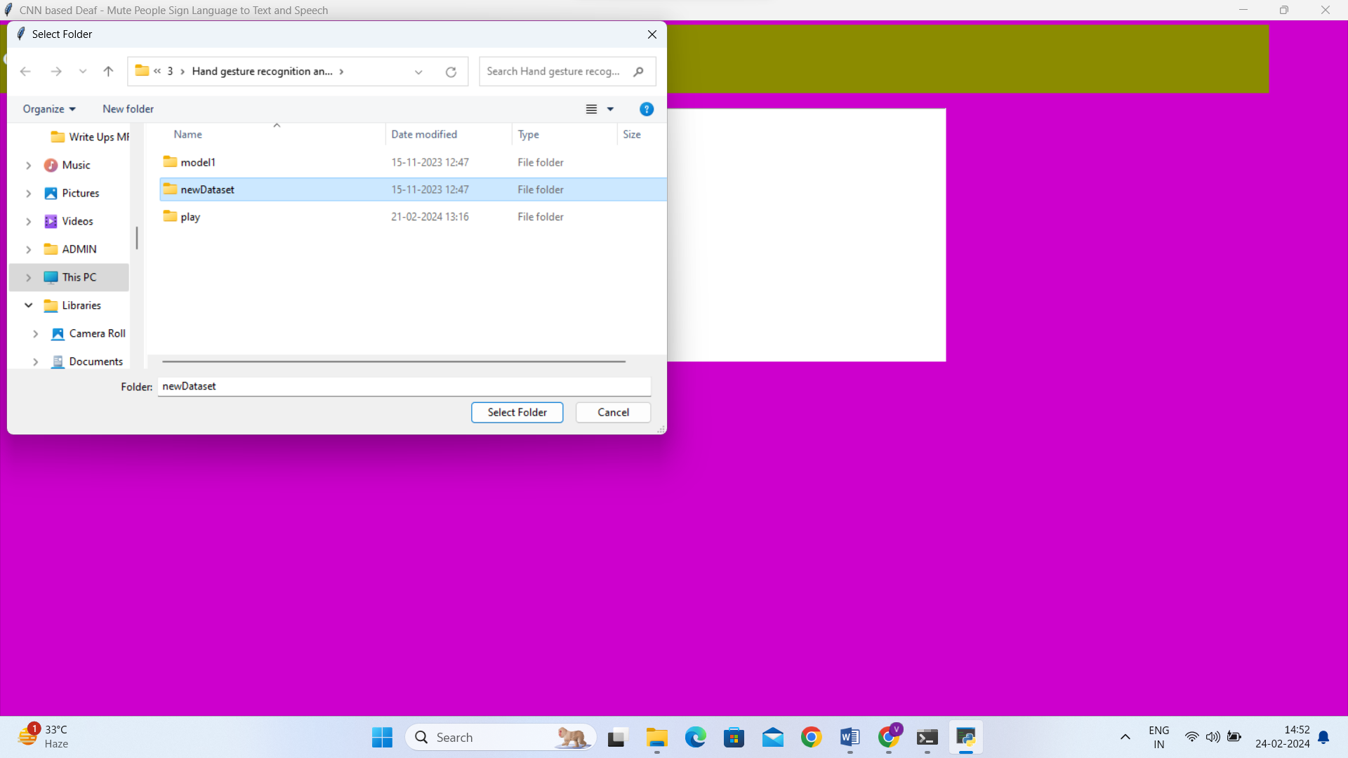

In above screen selecting and uploading ‘Dataset’ folder and then click on ‘Select Folder’ button to load dataset and to get below screen

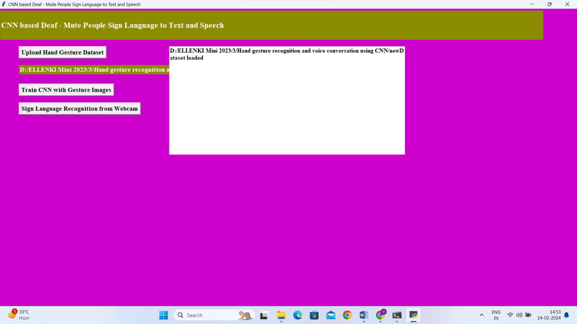

In above screen dataset loaded and now click on ‘Train CNN with Gesture Images’ button to trained CNN model and to get below screen

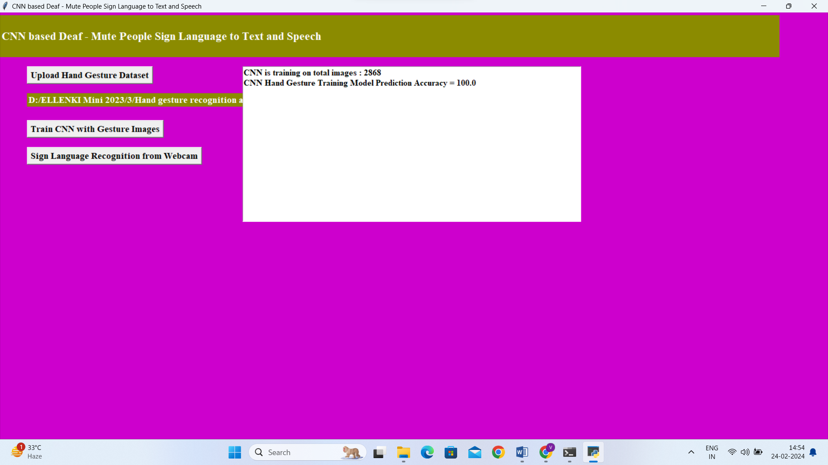

In above screen CNN model trained on 2000 images and its prediction accuracy we got as 100% and now model is ready and now click on ‘Upload Test Image & Recognize Gesture’ button to upload image and to gesture recognition

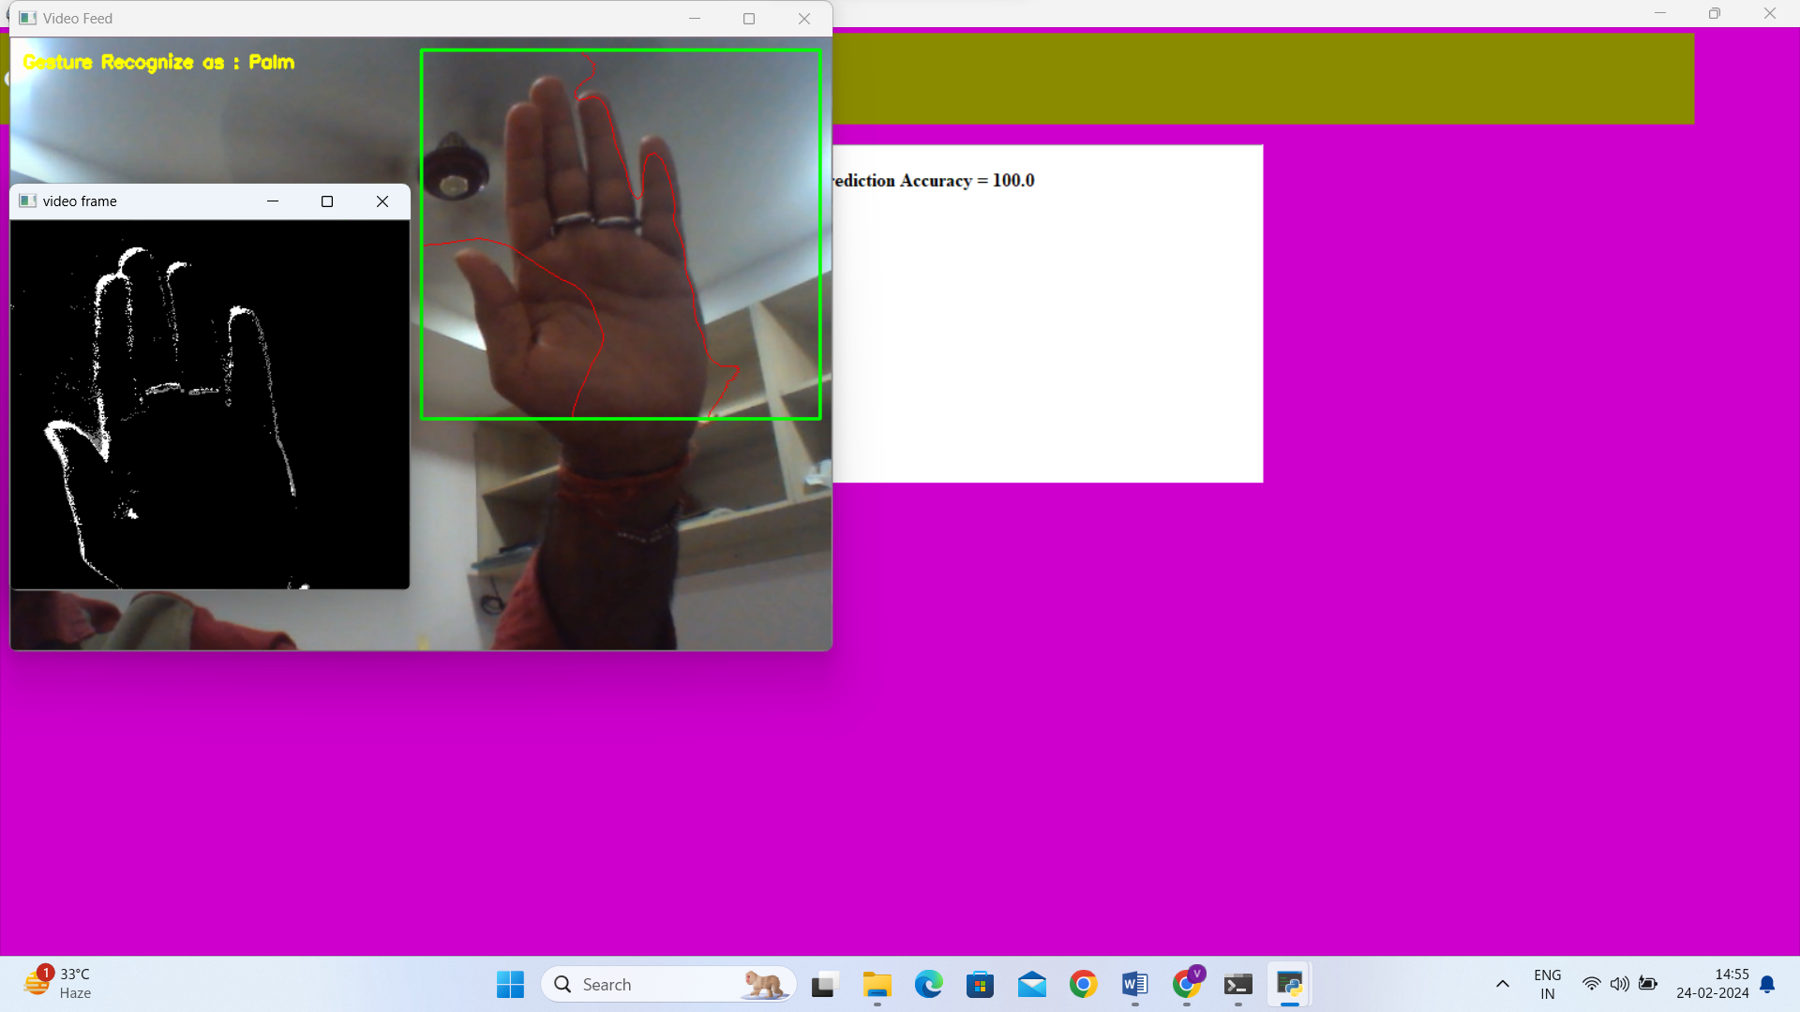

In above screen, by using webcam , for that sign langauge, it detected as palm as shown in the above text.

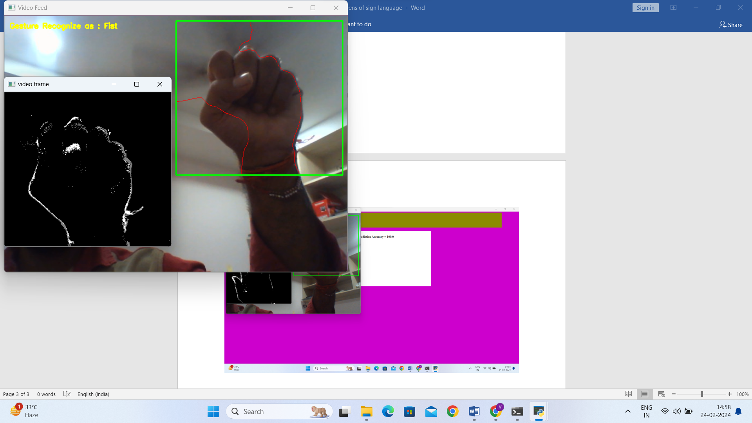

In above screen, by using webcam, for that sign language , it detected as fist as shown in the above text.

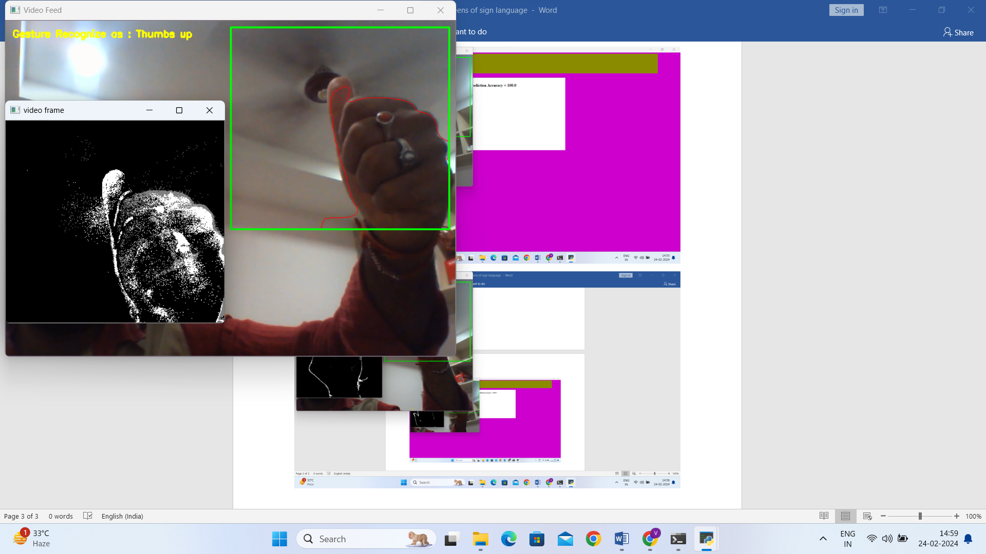

In above screen, by using webcam, for that sign language , it detected as thumbs up as shown in the above text.